Biology 357 Evolutionary Ecology – Handout 6

What is endosymbiosis? Who is credited with the idea?

What evidence supports the hypothesis that cattle egrets have a commensal relationship with cows?

Why are coral reefs undergoing bleaching?

Describe a mutualism with ants as one of the parties.

What is the distinction between obligate and facultative mutualism? Give an example of each.

Draw two trophic cascades, one with an even number of trophic levels and another with an odd number.
Using solid arrows, connect direct effects between parties in each trophic cascade. Mark indirect effects with dashed arrows, and discuss top-down versus bottom-up effects.

What is meant by competitive mutualism?

Diagram the indirect effects known as facilitation.

Write the Lotka-Volterra competition equations for two species and solve them for equilibrium population densities.

Make up a 2 x 2 table showing the 4 possible outcomes of competition under the Lotka-Volterra competition equations.

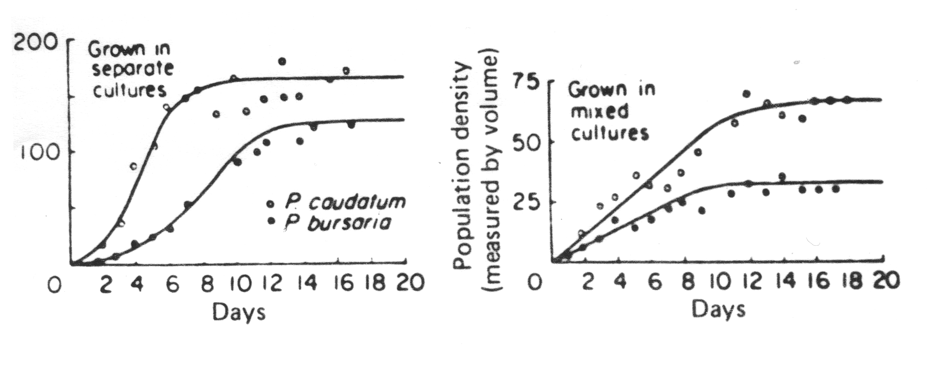
Use G. F. Gause’s data (above) to estimate competition coefficients between these two species of Paramecium.

Write equations for a mutualistic interactions between two species, define terms, solve for isoclines, and plot them on a graph. Show vectors of change in population density in all quarts and mark equilibrium population densities. What conditions are necessary for an equilibrium where both species can coexist?

